Lab: ORM Introduction

Creating a Django Project
We are going to create our first Django project. A Django project is like the blueprint for building a website or web app. It includes all the important instructions, tools, and parts needed to create your online creation. It helps you organize your code, manage website addresses, handle where your data is stored, and do many other important tasks. Just like a foundation for a house, a Django project gives you the basic structure to make your website work and do different things.
To create the project, we will be using PyCharm Professional as our integrated development environment. Let us launch the tool and navigate to File -> New Project:
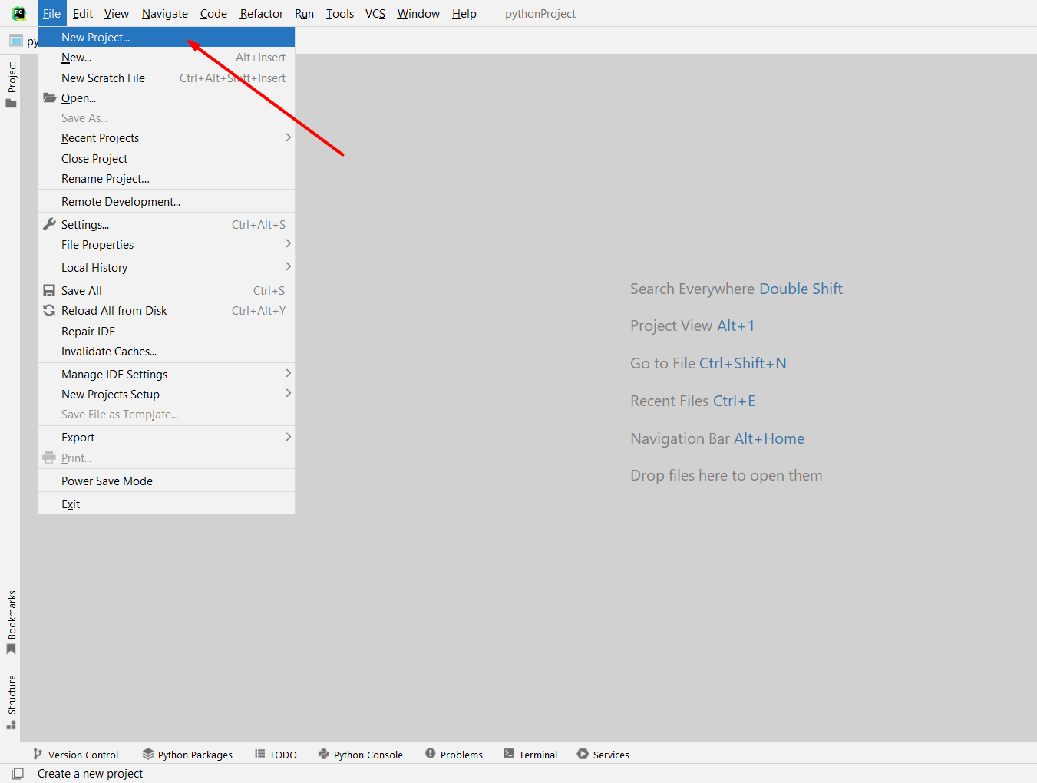
In the pop-up window, we will choose to create a Django project. Configure the project's location and name, ensuring the virtual environment is set up as well: 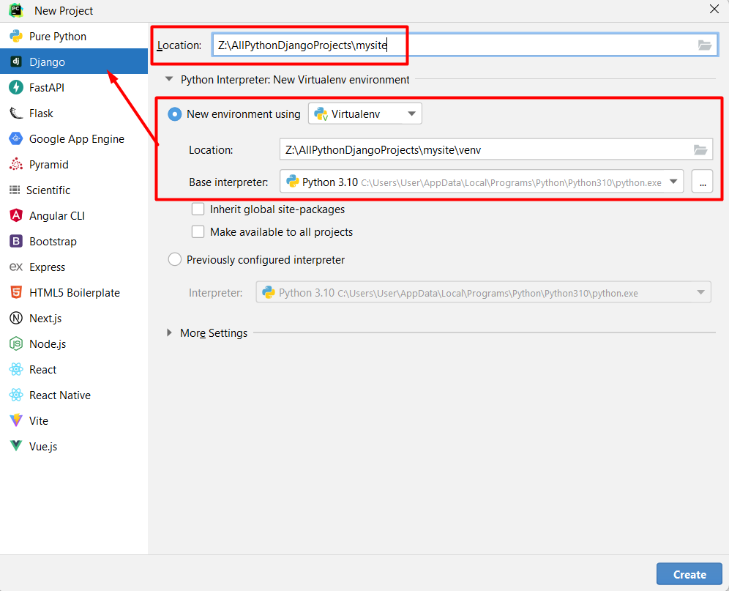
Click the "Create" button to initiate the project creation process: 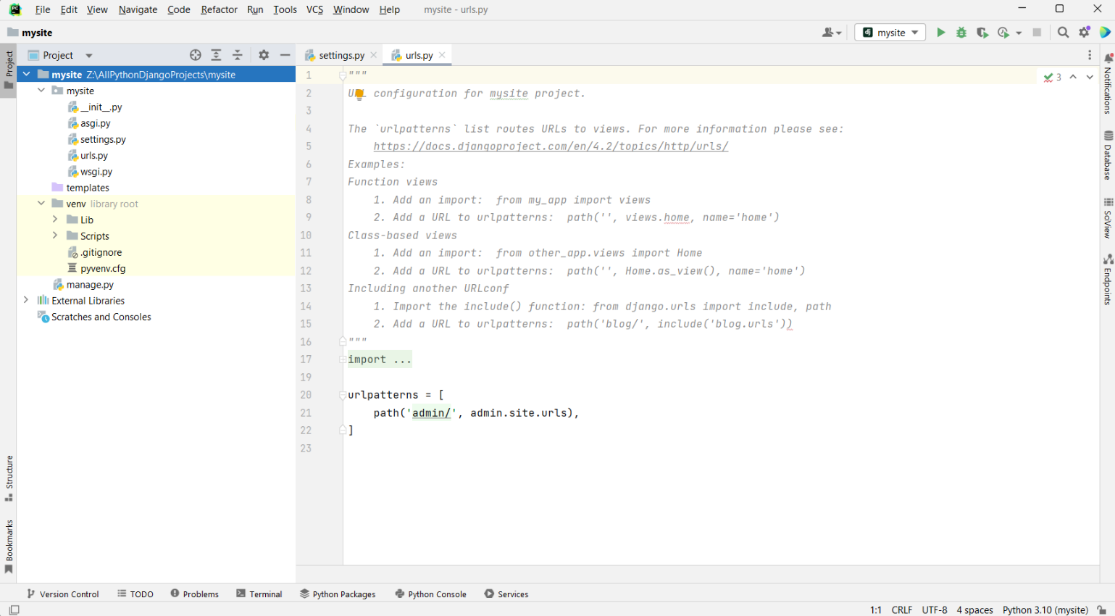

Next, let us check if the project is launching correctly. There are 3 ways of doing that:
- We can click on the PyCharm Run button. Note: Ensure the Django project is selected:
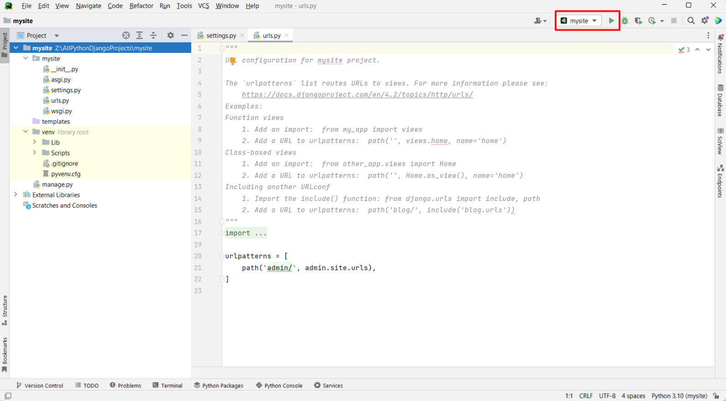

- We can start the project using the keyboard shortcut [Shift + F10]
- We can open the local terminal and type down the command "python manage.py runserver":
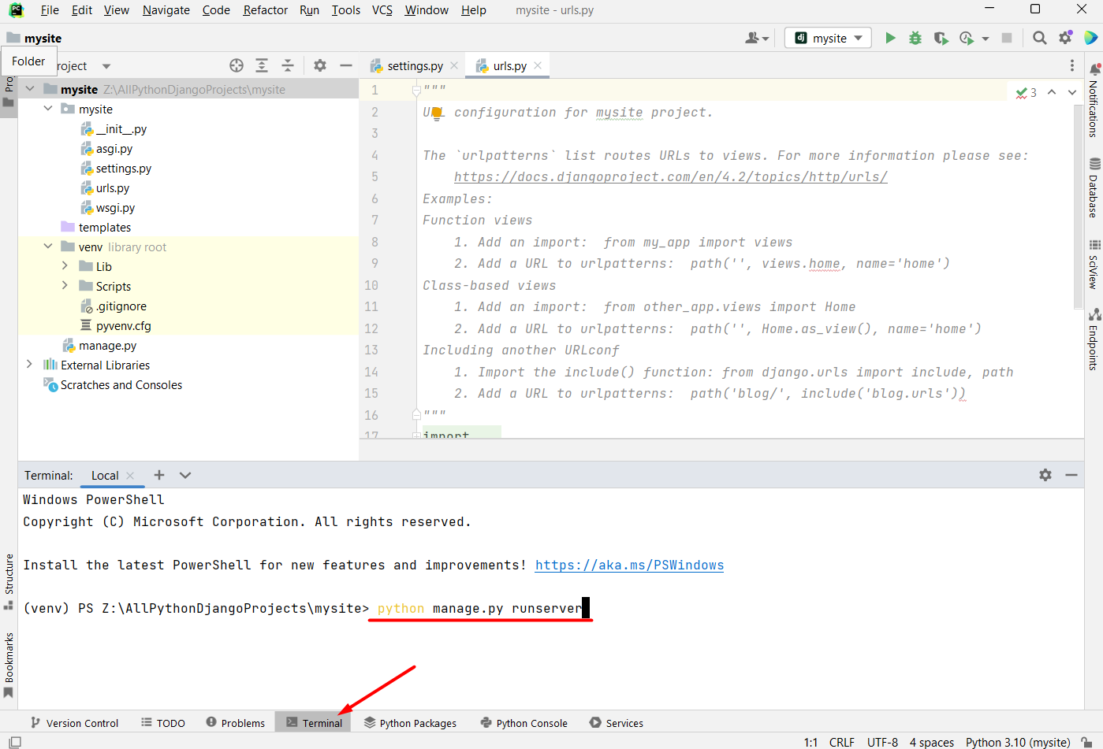

Either way, we should see the following output on the command line: 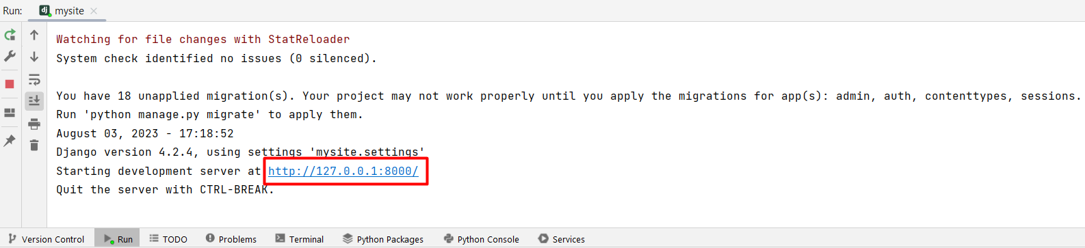
Click on the link and check if you see the following content: 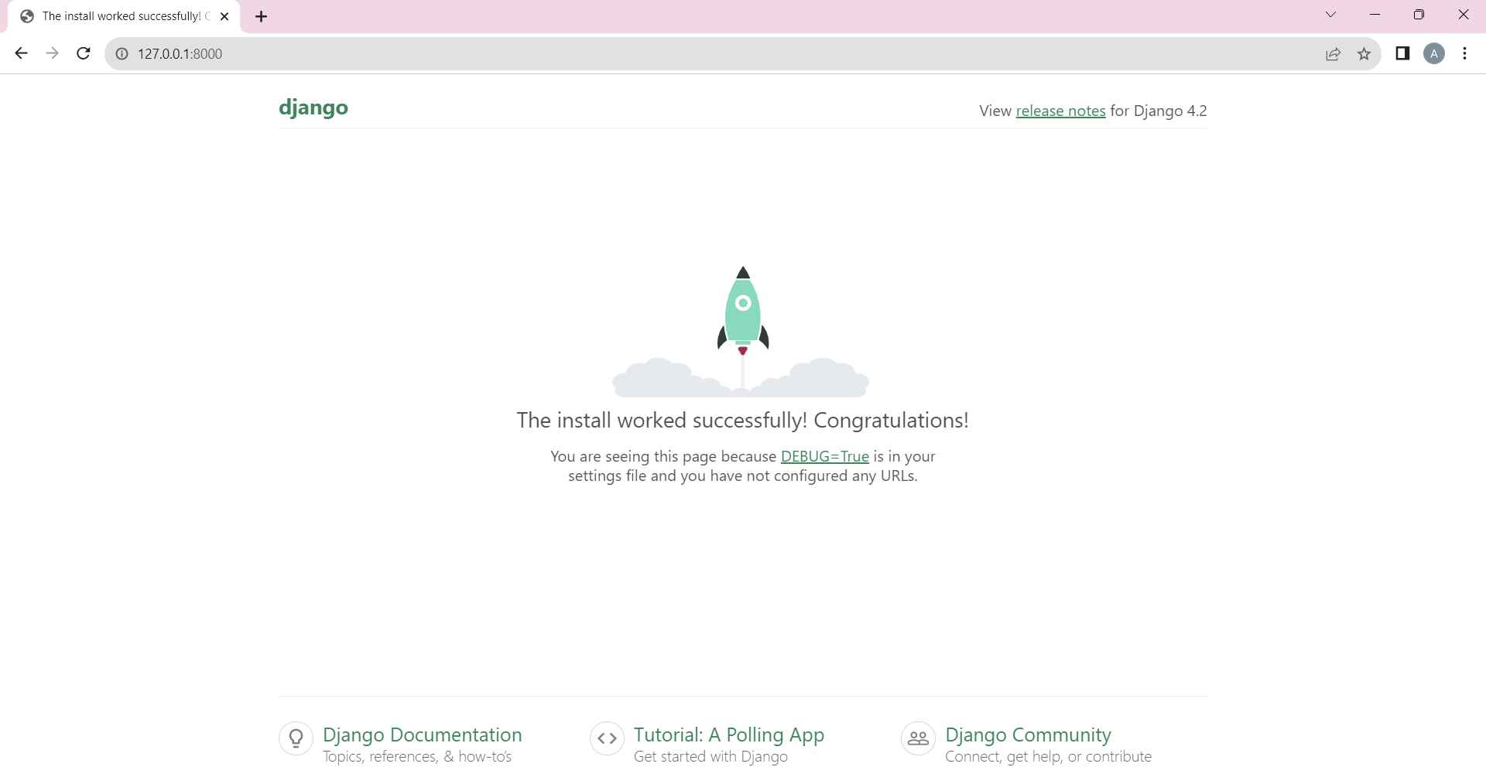

Creating a Django Application
Now, let us create our first Django application. In Django, an app is like a building block within a larger website or web application. It is a self-contained unit that contains all the code and functionality needed to perform a specific task or provide a particular feature. For example, an app can handle user authentication, manage blog posts, or process payments.
Let us access the local terminal again and type down the command "python manage.py startapp tasks". This will generate the desired Django application named "tasks":
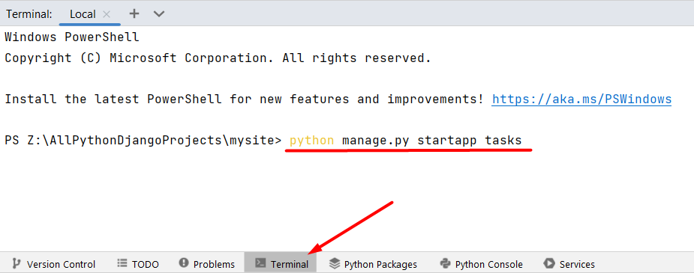

Django will automatically generate the essential components for the app: 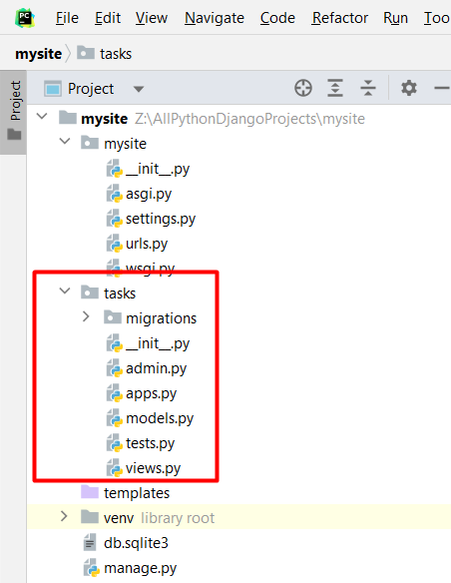

To integrate the app with the project, add its reference to the INSTALLED_APPS list within the settings.py: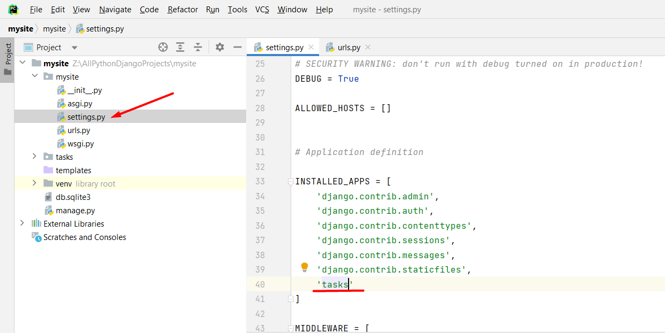
Note: If we chose to move the app inside the root directory of our Django project, we should consider the difference when integrating it: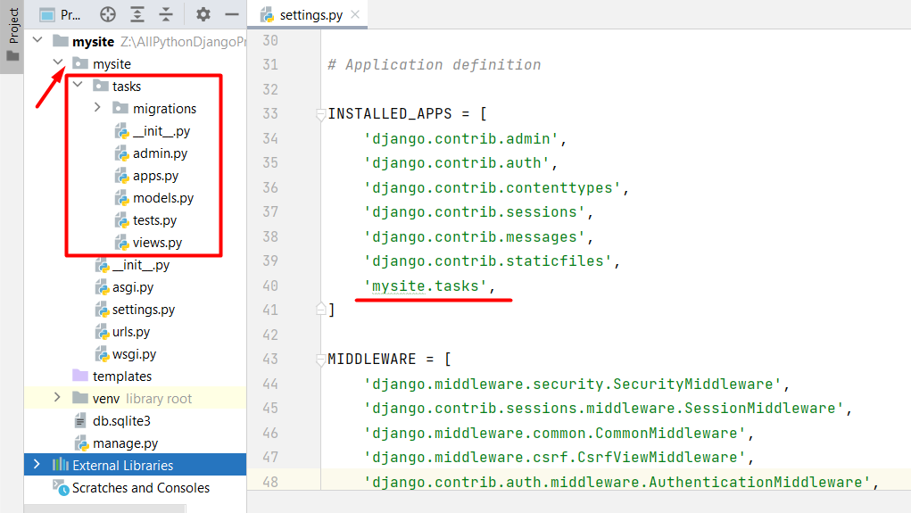

Introduction to the Ready-to-Use Skeleton

3.1 Opening the Project and Installing the Dependencies
For your convenience, we have prepared a ready-to-use skeleton for the needs of this course. Let us access the skeleton. Note: You can open the skeleton by right-clicking on the root folder if you have chosen "Update Context Menu / Add "Open Folder as Project" during PyCharm installation: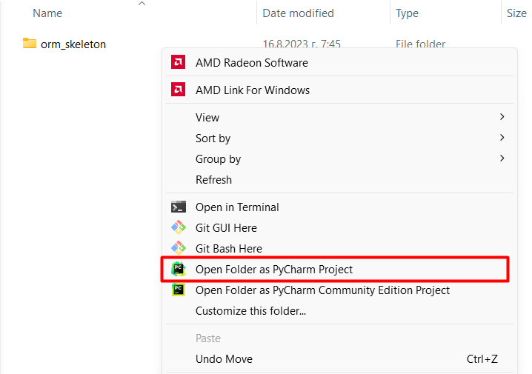
As the skeleton is opened, we need to ensure dependencies are met. We can accept PyCharm's suggested settings for creating a virtual environment with the base interpreter and required dependencies. The window should pop up automatically after opening the project: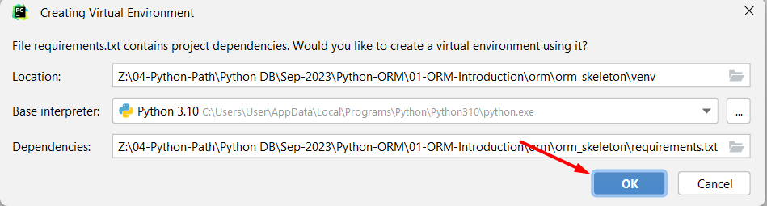

However, we can set it up manually. First, choose your preferred version of Python for a base interpreter: 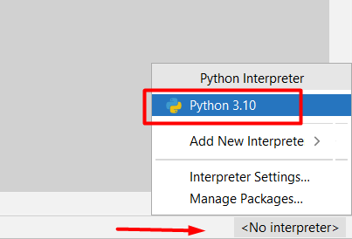

Afterward, we need to set up a virtual environment and activate it. This is done by executing two commands: "python -m venv ./venv" and "venv\Scripts\activate". Note that the first command creates a location for the virtual environment of the project; with the "./" we indicate that this venv should be created in the directory just above our current location: 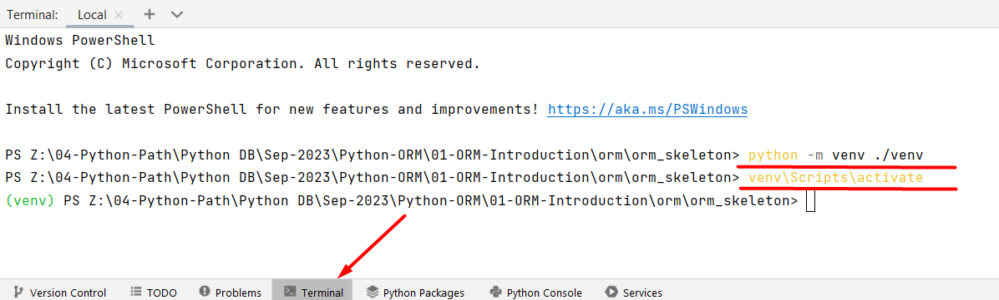

Once our virtual environment is ready, we proceed to install the required dependencies listed in the requirements.txt file. This is accomplished by entering the command "py -m pip install -r requirements.txt" in the terminal: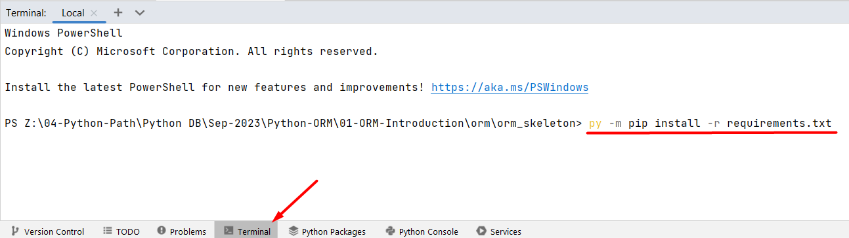
We can launch the development server (by clicking on the Run button) and check if the project is functioning correctly.

3.2 Skeleton Structure
Like a typical Django project, the skeleton structure has a root project directory called "orm_skeleton" and one pre-configured Django application directory called "main_app". You must not change the name of the directories!
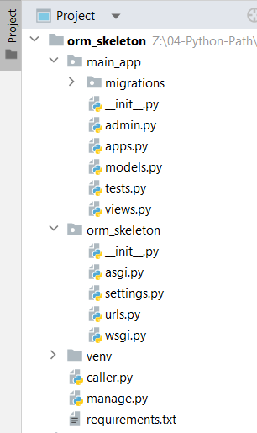
Also, there's an important file named "caller.py" included in the project. It sets up some necessary parts of Django which you MUST NOT erase. Throughout this course, we'll use the "caller.py" file to help us see the queries we run using Python code more clearly. Here we will practice working with queries that we have learned during the previous course, but we will not use direct PostgreSQL code in the pgAdmin interface. Instead, we will use Python code. We will create, read, update, and delete database records (rows):
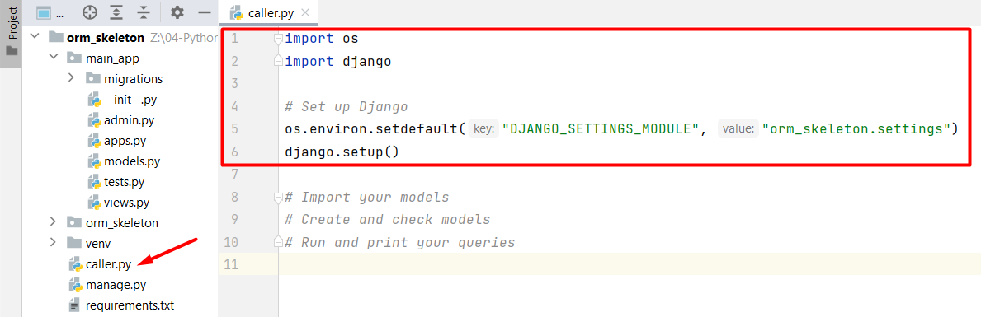

Configuring a PostgreSQL Database

4.1. Create a New Database using PyCharm Tool Window
As you see, in both the conventional Django project and the provided skeleton feature a database called sqlite3:
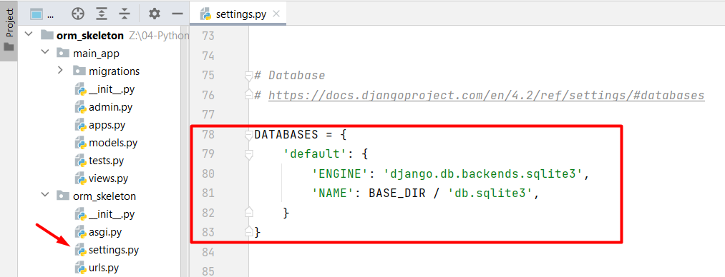
It is a database that Django uses by default to store and manage data for the web application. SQLite is a lightweight, serverless, and self-contained relational database management system, and Django supports it as one of its database backends. While SQLite is a great choice for small to medium-sized projects, larger projects might require more robust database systems like PostgreSQL, MySQL, or Oracle.
So, now we are going to configure a PostgreSQL database in the provided skeleton. First, let us access PostgreSQL. Click on the "Database" tool located on the PyCharm Tool Window. Since no data sources are currently defined, click on the "+" icon (meaning "New") to create one:
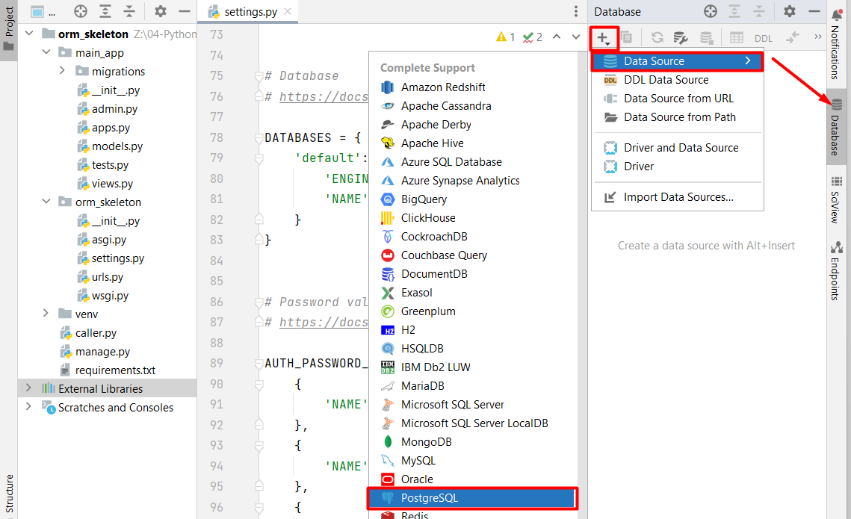
A dialog window will pop up on the screen, where we can add our credentials - the username and password that we use to connect to PostgreSQL: 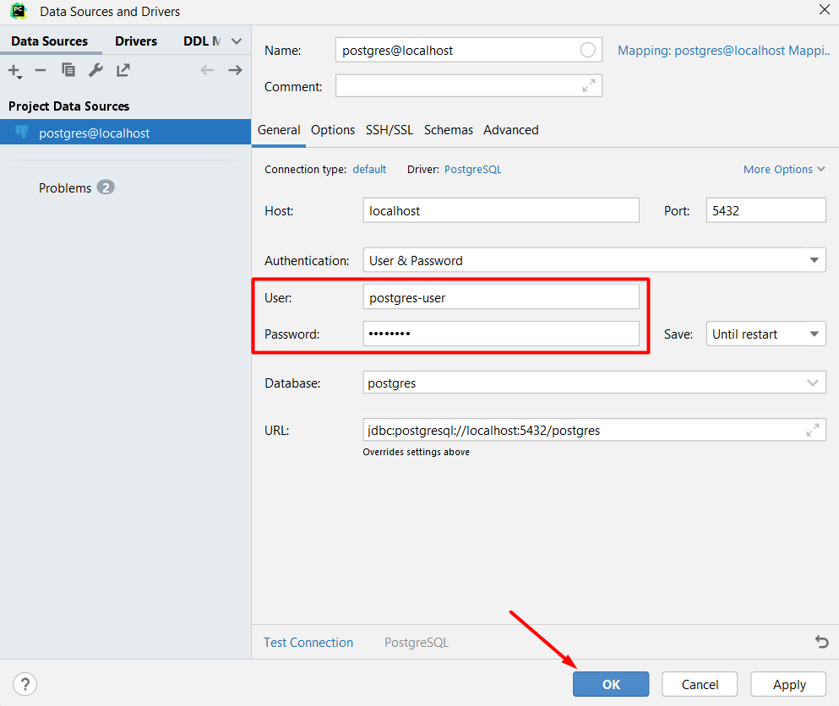
As we have connected to the data source, we now need to create a database in which all the data from the current project will be saved. Right-click on the source and choose to create a new database: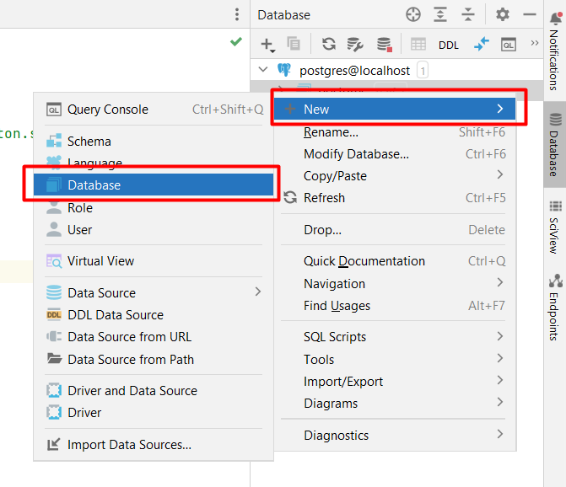
We will name the database "my-site-database", but you are free to name it with your individual preferences: 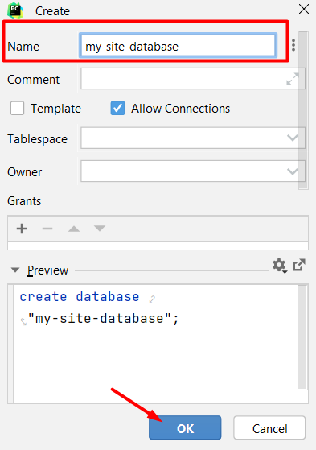
To see the changes made, right-click on the data source and refresh the interface: 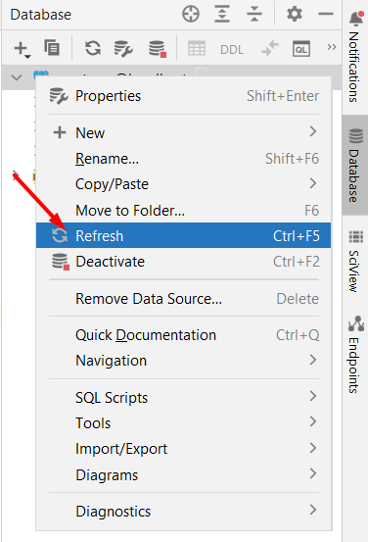
Now, we will be able to see the newly created database:
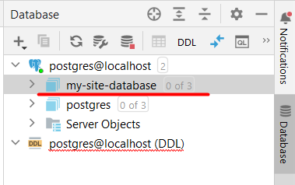

4.2. Configure the Database Settings
We are already aware that Django comes with a built-in database called SQLite by default. However, for our purposes, we want to switch to using PostgreSQL. To make this change, we will go to the "settings.py" file. Inside the "DATABASES" section, there's a piece of code that shows the project is currently set to use SQLite: 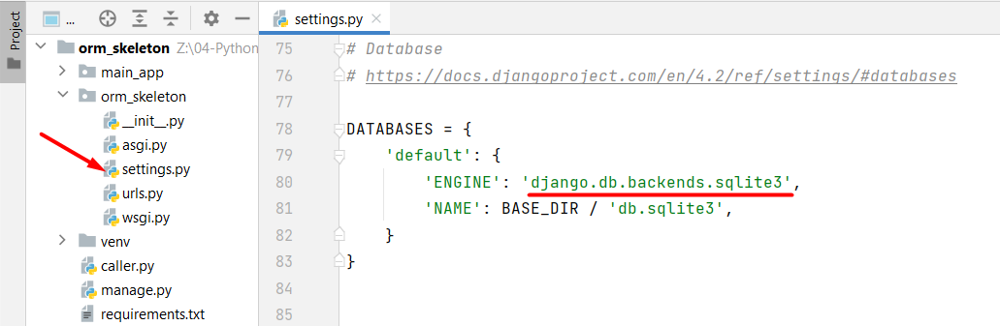
We need to modify that part, so it uses the PostgreSQL database we have just created. Add the following code:
DATABASES = {
'default': {
'ENGINE': 'django.db.backends.postgresql',
'NAME': 'my-site-database',
'USER': 'postgres-user',
'PASSWORD': 'postgres',
'HOST': 'localhost',
'PORT': '5432',
}
}
Let's break down each key-value pair in this configuration:
- 'ENGINE': Specifies the database backend to use. In this case, 'django.db.backends.postgresql' indicates that the PostgreSQL database engine will be used. Note that this engine needs the psycopg2 adapter to connect to PostgreSQL.
- 'NAME': This is the name of the database we want to connect to. In our case, it's set to 'my-site-database'. This is where our project's data will be stored.
- 'USER': Specifies the username to use when connecting to the PostgreSQL database. Replace 'postgres-user' with the actual username you will use.
- 'PASSWORD': Specifies the password for the provided username. Replace 'postgres' with the actual password.
- 'HOST': Indicates the host where the PostgreSQL database server is running. In this case, it's set to 'localhost', meaning the database server is on the same machine as our Django project.
- 'PORT': Specifies the port number on which the PostgreSQL database server is listening - it is set to '5432' - the default port for PostgreSQL.

4.3. Install the Database Driver
Now, we can install the PostgreSQL adapter psycopg2 with the command "pip install psycopg2" using the local terminal:
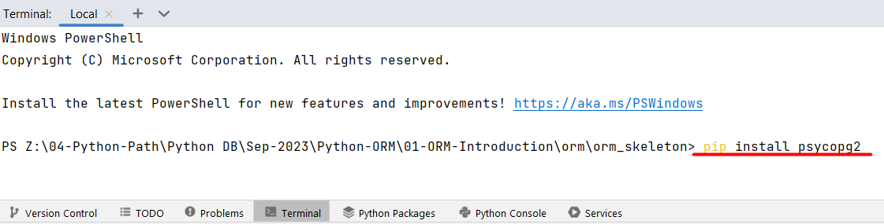
Finally, we are ready to use the database in our Django project. We can make a fast check by typing the command "python manage.py migrate" which will create all the tables that were predefined in the Django project: 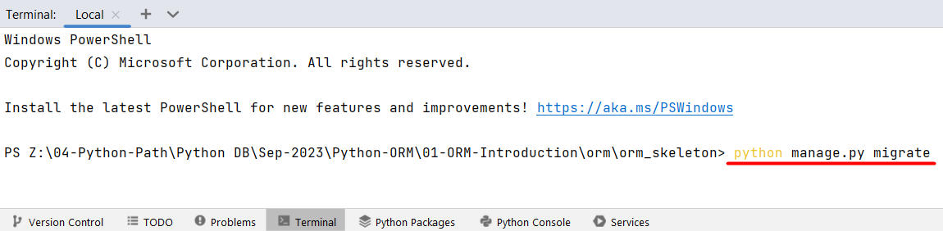
Note: The command will be discussed in detail in the upcoming lessons. At the moment, you do not need to concern yourself with understanding it further.

Django DB Shell

5.1. Opening the Django dbshell
It is time to dive into the Django dbshell and practice our knowledge. Open the terminal and type down the command which starts the dbshell "python manage.py dbshell":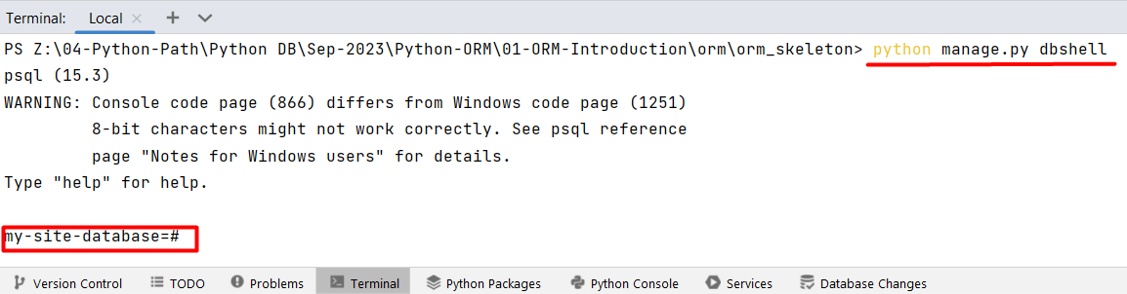

5.2. Receiving CommandError for Windows Users
If you are using Windows OS, you might encounter a common issue when you first run the command. You might see a CommandError saying "You appear not to have the 'psql' program installed or on your path.": 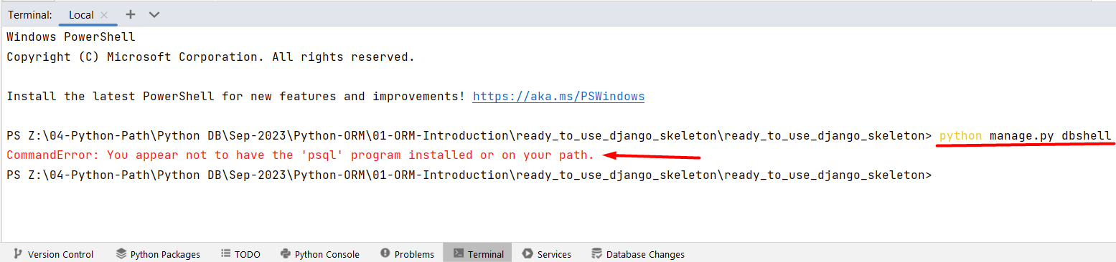
To solve this problem, you will need to adjust your computer's settings.
First, let us locate our PostgreSQL binary path. For example, Windows users usually find it at "C:\Program Files\PostgreSQL\15\bin" (it can vary based on the PostgreSQL versions or where you have saved the installation files).
Next, access the system settings and search the "Edit the system environment variables" window. Afterward, click on the "Environment Variables" button in the "Advanced" System Properties:
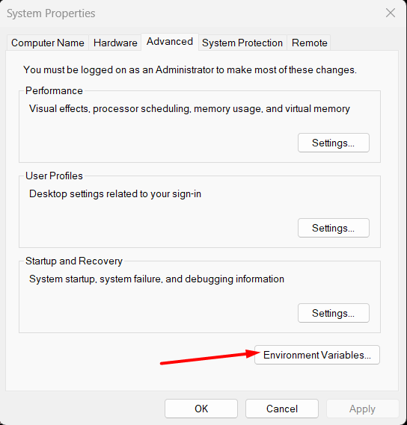
Find and click on the "Path" system variables, so we can edit them: 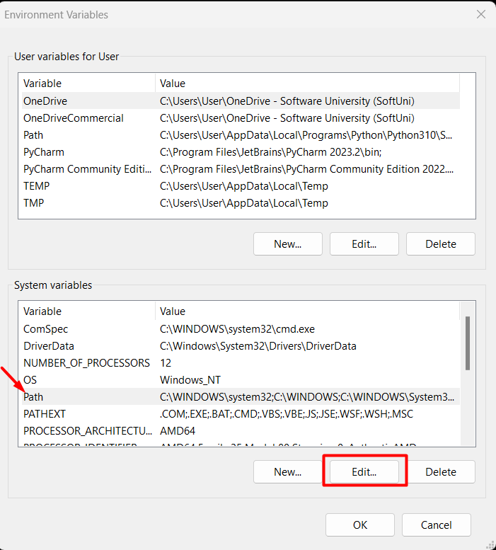

Finally, we need to add the path to the PostgreSQL installation files. Click on the "New" button and add it: 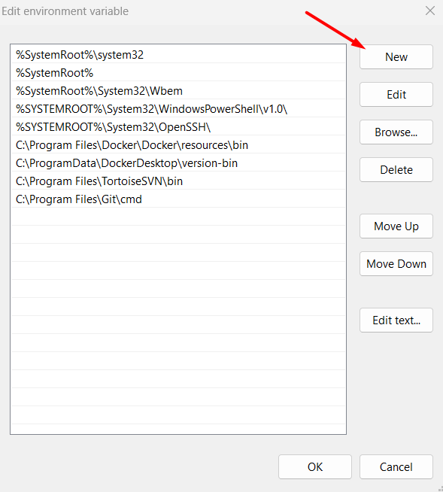
After making the addition, we just need to confirm the changes by clicking on the "OK" button:
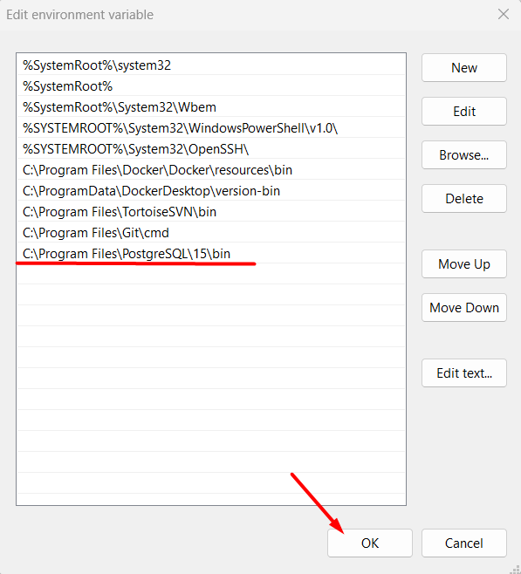
Note: We MUST restart the IDE in order to execute the command correctly:
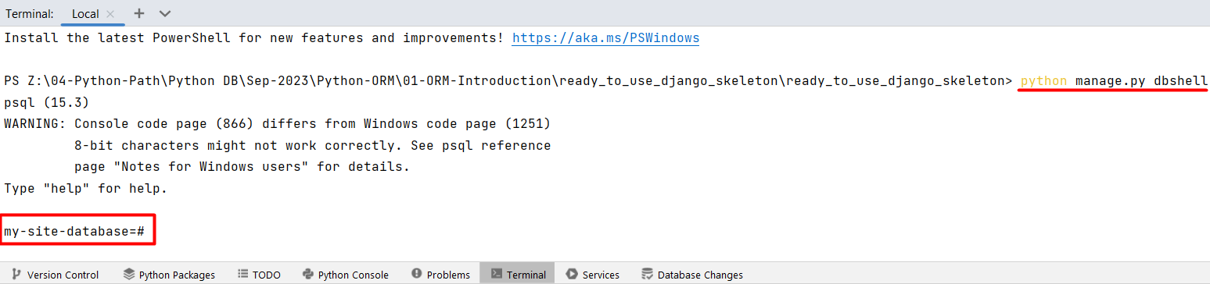

5.3. Receiving CommandError for Mac Users
If you are using Windows OS, you might encounter a common issue when you first run the command. You might see a CommandError saying "You appear not to have the 'psql' program installed or on your path.": 
To solve this problem, you will need to run the command "brew install postgres". In case your machine does not have brew installed, you need to install it.

5.4. Working with the Django dbshell
Let's begin by displaying all the tables in our database running the commands "\dt":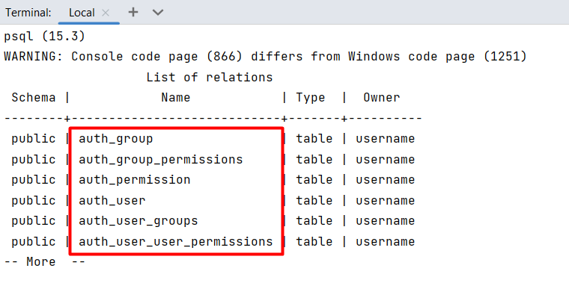
These are the tables predefined within every Django project. Note: We will examine them closely in the next Django course.
Moreover, we can access information about a specific table by executing the command "\d <table_name>". Let us take a closer look at the "auth_group" table:
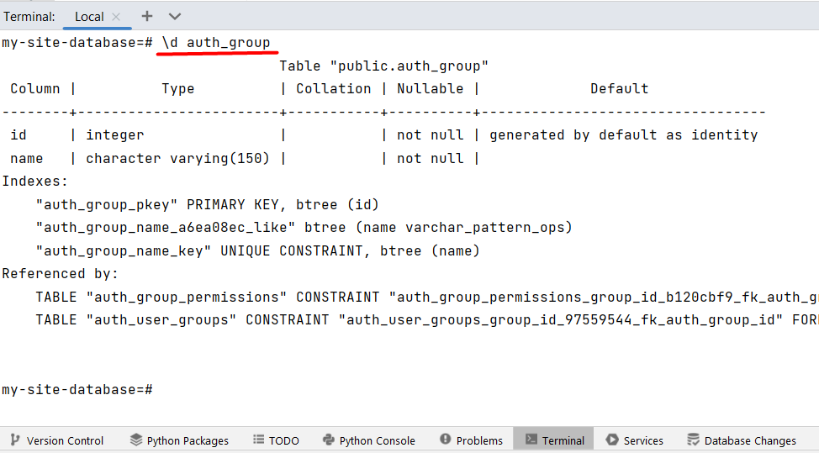
The fundamental aspect of using the dbshell is that we can execute raw SQL queries directly within our project's database through the local terminal. For example, we can retrieve all the data from the initial table: 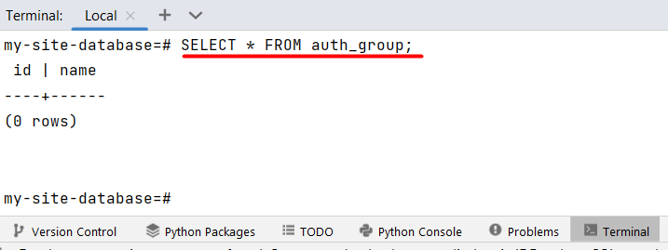

The table appears empty because we have not added any records to it yet.
For the purposes of this lab, we will create a table named "people" using raw SQL code. Note that we can write the SQL statement on multiple lines. As long as the statement is not concluded with a ";" the program treats it as a single instruction:
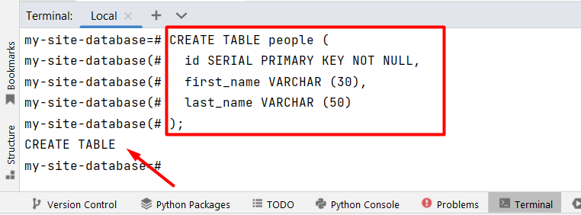
We can check if the table is created properly by typing the command "\d people":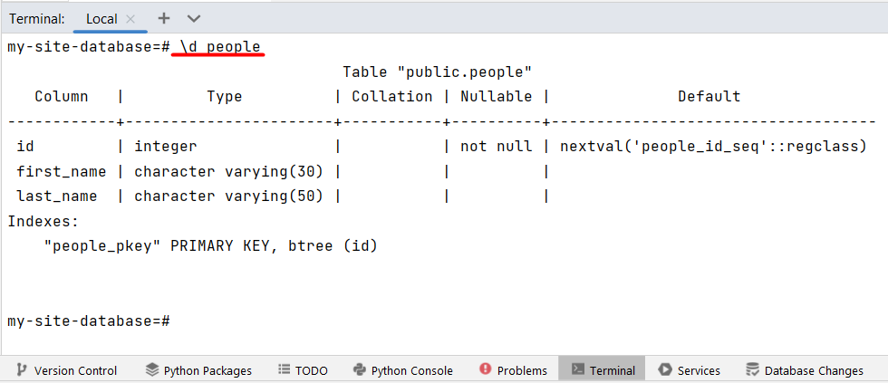
Furthermore, the table is visible within the Database PyCharm Tool:
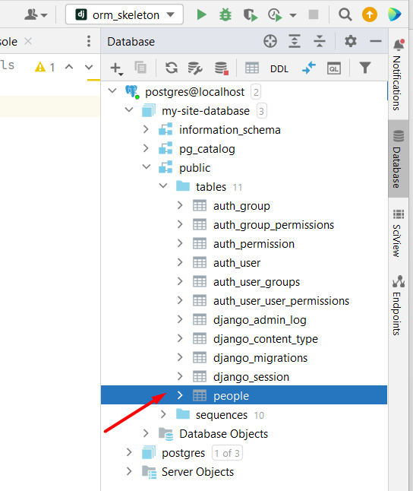
Now, let us add some records (rows) to the "people" table: 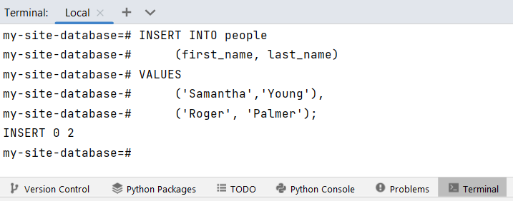
Subsequently, we can verify the inserted data: 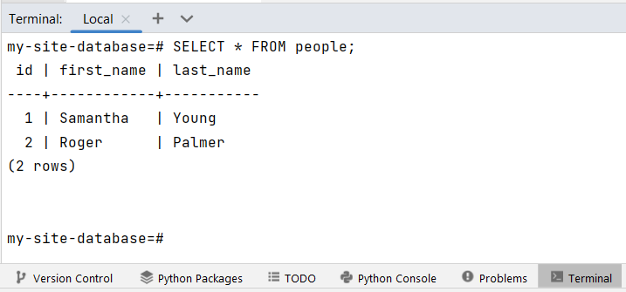
For a more interactive exploration of the inserted data, the Database PyCharm Tool comes in handy. By right-clicking on the "people" table and selecting "Edit Data" from the menu, we gain access to a user-friendly interface:
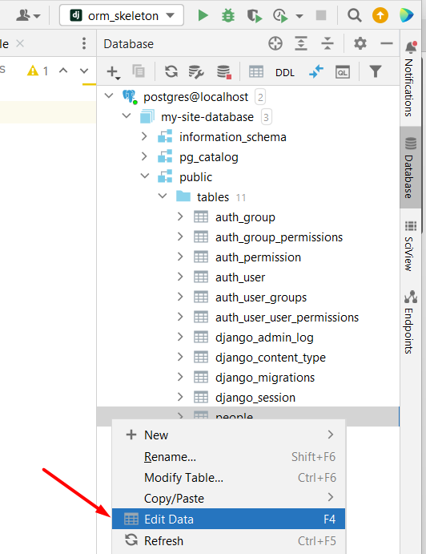
Here we can find our data: 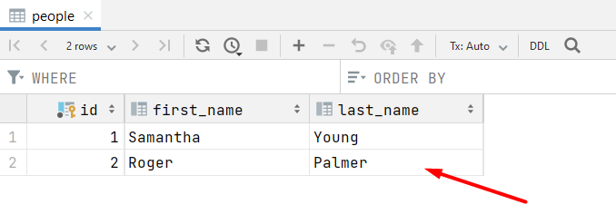
From this interface, we can add rows of data: 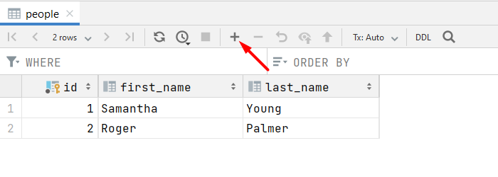
We need to submit the newly added data:
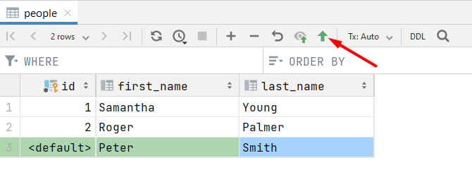
Our exploration of the dbshell within the context of Django has revealed a valuable tool for direct interaction with the database. We have learned that the dbshell enables us to execute raw SQL commands directly through the terminal, granting us direct control over database operations. This newfound understanding of the dbshell equips us with an effective method for navigating and interacting with databases within the Django framework.

